**Golden Eagle Inc.**



*Communication Systems*

Dylan Lam

Joyce Lam

Weifeng Huang

Jiri Kral

CIS 4840 Section 02 Group 3

Fall 2021

**Group Information**

|  |  |  |
| --- | --- | --- |
| **Member Name** | **Percent Contribution** | **Activities Completed by Member** |
| Dylan Lam | 30% | Network Needs Analysis, Network Diagrams & Topologies, System Components & Statement of Work |
| Joyce Lam | 30% | Feasibility Study, Acceptance & Authorization, Disaster Recovery Plan |
| Weifeng Huang | 20% | Introduction, Background |
| Jiri Kral | 20% | Scope of Work, System Setup Documentation |
| **Total** | **100%** |  |

**Table of Contents**

**1 Introduction** **3**

**2 Background** **3**

**3 Scope of Work** **3**

3.1 Problem Statement 3

3.2 Proposal Objectives 3

3.3 Deliverable 3

3.4 Timeline and Agreement 4

**4 Feasibility Study** **4**

4.1 Project Situation 4

4.2 Network Scope 4

4.3 Objectives 4

4.4 Design Features 5

4.5 Design Assumptions 5

**5 Network Needs Analysis** **5**

5.1 Data Types 5

5.2 Data Sources 5

5.3 Number of Users and Priority Levels 6

5.4 Transmission Speed Requirements 6

5.5 Load Variation Estimates 6

5.6 Reliability Requirements 6

5.7 Security Requirements 6

5.8 Existing Networks 6

5.9 Requirements 6

**6 Network Diagrams & Topologies** **7**

Figure 1: Salazar Hall 3rd Floor - Network Diagram 7

Figure 2: Salazar Hall 3rd Floor - Topology 8

Figure 3: Classroom/ Office 9

Figure 4: Lab 9

**7 System Components & Statement of Work** **10**

**8 Disaster Recovery Plan** **11**

**9 Acceptance & Authorization** **12**

**10 System Set Up Documentation** **12**

10.1 Physical Network Components Architecture 12

10.2 Network Security Architecture 13

10.3 Active Directory Domain Services 14

## **1 Introduction**

Golden Eagle Inc. is a network company for designing the local network for customers. A network is a must for every business at this time. Our goal is to provide a high-quality network design service. Our team members include Dylan Lam, Jiri Kral, Joyce Lam, and Weifeng Huang. We will provide the network design, hardware requirements, software requirements, and fees for our clients.

## **2 Background**

The client is California State University Los Angeles which is located in Los Angeles, California. It is a university. The university needs to provide classrooms for students who need access to computers and networks. The building is called Salazar Hall. The building has three floors. We will handle the 3rd floor’s network design. The classroom on this floor includes an electronic classroom and a technology-enhanced classroom. It has 25 rooms. The school will need these classrooms for courses like CIS, which need computers or a computer lab.

## **3 Scope of Work**

### **3.1 Problem Statement**

In this project, our team is going to address the Request for Proposal (RFP) of a new network design for Salazar Hall at California State University in Los Angeles whose network infrastructure no longer meets today’s industry requirements.

### **3.2 Proposal Objectives**

This network design proposal for the 3rd floor of Salazar Hall will provide an approximate budget overview and the technological framework for the implementation of a secured, reliable, scalable, and maintainable network that follows modern industry standards.

### **3.3 Deliverable**

A complete network design proposal that includes an analytical overview, logical network topologies, and diagrams, network infrastructure components, system setup documentation, disaster recovery plan, and predicted budget requirements.

### **3.4 Timeline and Agreement**

Golden Eagle Inc. team together with the requestor, Professor Fu, agreed to work on the network design proposal starting on October 3rd, 2021. Both parties agreed on the RFP due date, December 1st, 2021.

## **4 Feasibility Study**

### **4.1 Project Situation**

This proposal is for a network design on the third floor at Salazar Hall to service the California State University, Los Angeles.

### **4.2 Network Scope**

The proposed network is designed to serve California State University Los Angeles, which will consist of 25 rooms on the 3rd floor of a three-floor building.

The rooms on the 3rd floor of the building will be eleven classrooms, eleven computer labs, one women’s restroom, one men’s restroom, one office, three exits, and one electrical room.

### **4.3 Objectives**

The network is designed to achieve several specific business and operational objectives:

1. *Secure Services*: The main objective of this network is to provide secure administrative computing services to the 3rd floor of Salazar Hall at California State University Los Angeles. It is designed to be functionally and physically isolated from access by people not employed or attending California State University Los Angeles to minimize the risk of unauthorized use.
2. *Integration and Update*: This is a new installation in an already built building. The network and equipment being installed will be new equipment designed for the 3rd floor of Salazar Hall at California State University Los Angeles.
3. *Versatile Information Processing*: The network will enable users to retrieve, process, and store data regarding the operation of the 3rd floor of Salazar Hall at California State University Los Angeles.
4. *Scalability*: The network design is scalable so that more network cable equipment can be added if needed and as funding becomes available without having to redo the installed network.

**Intended Users:** The users of the network will be the students and faculty.

### **4.4 Design Features**

**Classrooms**

The classrooms will have one administrative workstation per room, each described below:

* Workstation - computer, monitor, mouse, projector, and keyboard
* Cat 6 cabling

**Computer Labs**

The computer labs will consist of thirty workstations for students to use in class. Each workstation will consist of a computer, keyboard, mouse, and monitor with speakers built into the monitor.

* 30 workstations
* 1 administrative workstation
* 1 printer
* Cat 6 cabling

### **4.5 Design Assumptions**

This design assumes the following:

1. The network and all the equipment will be new installations.
2. Internet service will be provided by an Internet Service Provider such as Spectrum

## **5 Network Needs Analysis**

### **5.1 Data Types**

The types of data served by the California State University, Los Angeles’ network will be reports, student/ faculty profiles, bulletins, up-to-date applications/ browsers, blogs containing current news/ events, web pages, and a variety of industry-specific software. It is guaranteed that there will be background graphics and a moderate amount of voice and video data due to the ongoing pandemic and remote learning.

### **5.2 Data Sources**

Data will be created and utilized at all electronic classrooms (EC) and technology-enhanced classrooms (TEC) as well as the open-access lab (OAL) on the third floor of Salazar Hall. The data will be produced by all software applications in a Windows 10 environment in all rooms and Windows Server 2019 on the server-side. Office 365 will be utilized to satisfy the universal needs in all majors if not industries. This includes the latest Microsoft products such as Word, Excel, PowerPoint, Access, Outlook, etc. Other data sources are supported as well as all software applications, industry-specific or not, will be up-to-date for all students and faculty members to use. This includes Adobe, IBM, Oracle, SAP, SAS, Notepad++, IDEs that utilize one or more programming languages, and much more. In addition, the university’s network and its software applications can be accessed from off-campus, however, not all software applications are available off-campus.

### **5.3 Number of Users and Priority Levels**

On the third floor of Salazar’s Hall, it is estimated that the maximum number of users on the network at any given time is 350. All computers in a lab/ classroom will be given top priority over any personal computers brought in by faculty or students.

### **5.4 Transmission Speed Requirements**

The network is transparent to all users as the transmission speed will be around 1 Gbps (or 100 Mbps).

### **5.5 Load Variation Estimates**

Based on the information provided by one of our group members and the university, the busiest times on the third floor of Salazar’s Hall will be Monday to Friday between 11:00 AM to 4:30 PM and 6:00 PM to 8:00 PM.

### **5.6 Reliability Requirements**

To meet user expectations and industry standards, the wireless local area network (WLAN) will operate at a 99.9% uptime and efficiency as well as an undiscovered error rate of 0.01%.

### **5.7 Security Requirements**

The network will utilize 802.11i (WPA2) security measures as it is the gold standard in 802.11 security. Aside from that, a firewall will be implemented to restrict unauthorized users from gaining access to the network. User authentication will be used as well since it identifies if the user is authorized through the use of user accounts and passwords. If the user is authorized, the user will be given access to the device/ network.

### **5.8 Existing Networks**

There is an existing network on the third floor of the building. However, it needs to be upgraded to comply with today’s standards. Thus, this proposal is the key to upgrading the existing network.

### **5.9 Requirements**

* Software:
  + Microsoft Windows 10 on all computer workstations (wired or wireless)
  + Microsoft Server 2019 on the server (network operating system)
  + F-Secure Anti-virus software on all servers and clients
  + Microsoft Office 365
  + Industry-specific software/ products (i.e. Adobe, IBM, etc.)
  + Programming/ Scripting Languages (i.e. Python, Java, C, SQL, etc.)
  + All updates and service packs installed and up-to-date
* Multi-function devices (copy, fax, print, scan)
* Switches
* Wireless access points
* Cabling and Connectors
* Computer Workstations
* Server(s)
* 802.11i (WPA2) and Firewall
* Modem (provided by an Internet Service Provider (ISP))

## **6 Network Diagrams & Topologies**

#### **Figure 1: Salazar Hall 3rd Floor - Network Diagram**

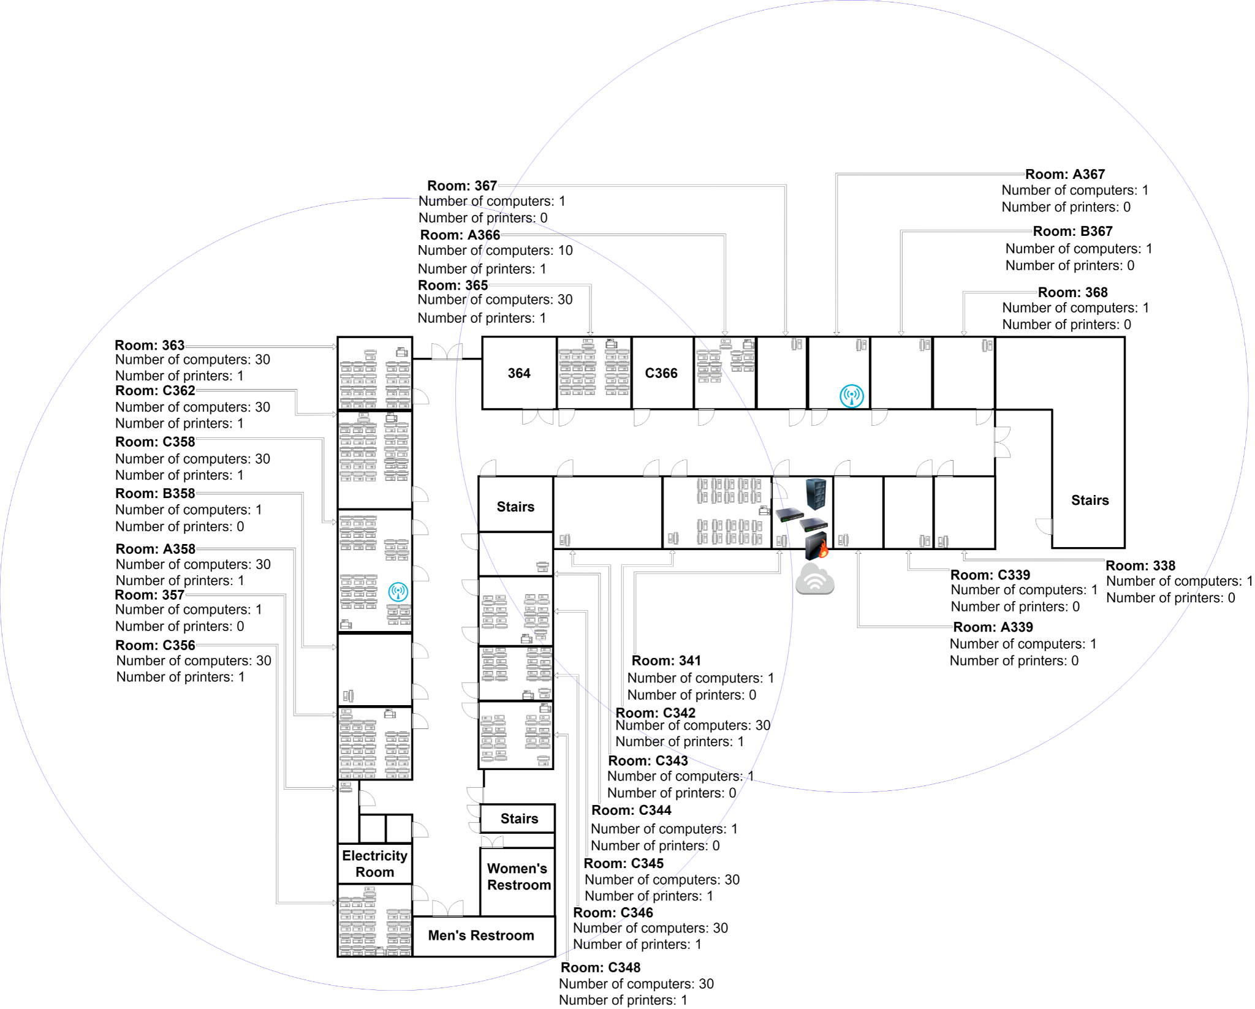

* The radius of both wireless access points are precisely scaled. Adjusting them in the field is required to gain good coverage. Furthermore, the 1st and 2nd floors of Salazar Hall must be considered after implementing the wireless access points.
* The server and switches are located in Room 341 as this room will be the office on this floor.
* The wireless access points are located in Room C358 and A367.
* Classrooms are classified as rooms containing only 1 computer.
* Labs are classified as rooms containing 30 computers including 1 printer. The only other lab has 10 computers and 1 printer which is Room A366.
* The number of computer props on the diagram does not represent the actual number of computers. Only for conceptual purposes.

#### **Figure 2: Salazar Hall 3rd Floor - Topology**

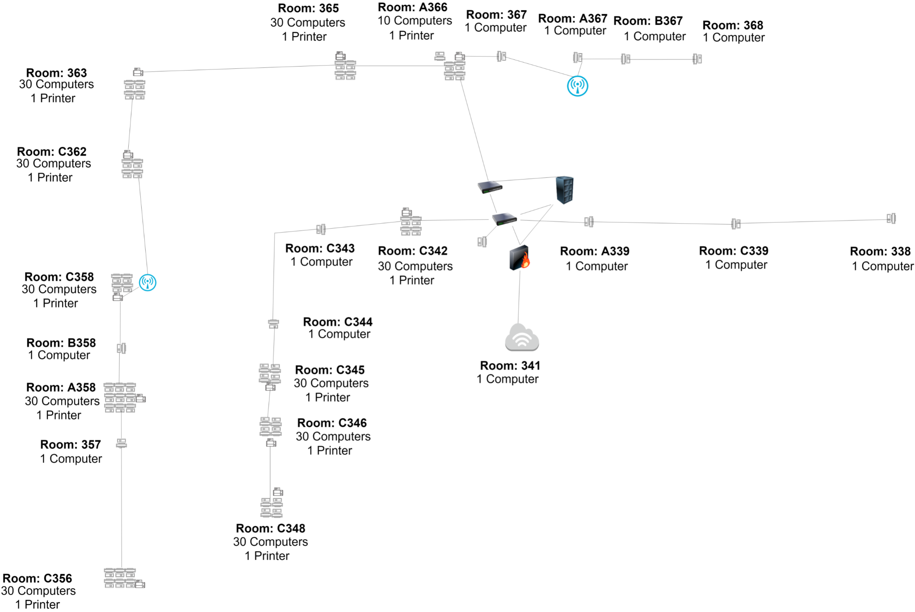

#### **Figure 3: Classroom/ Office**

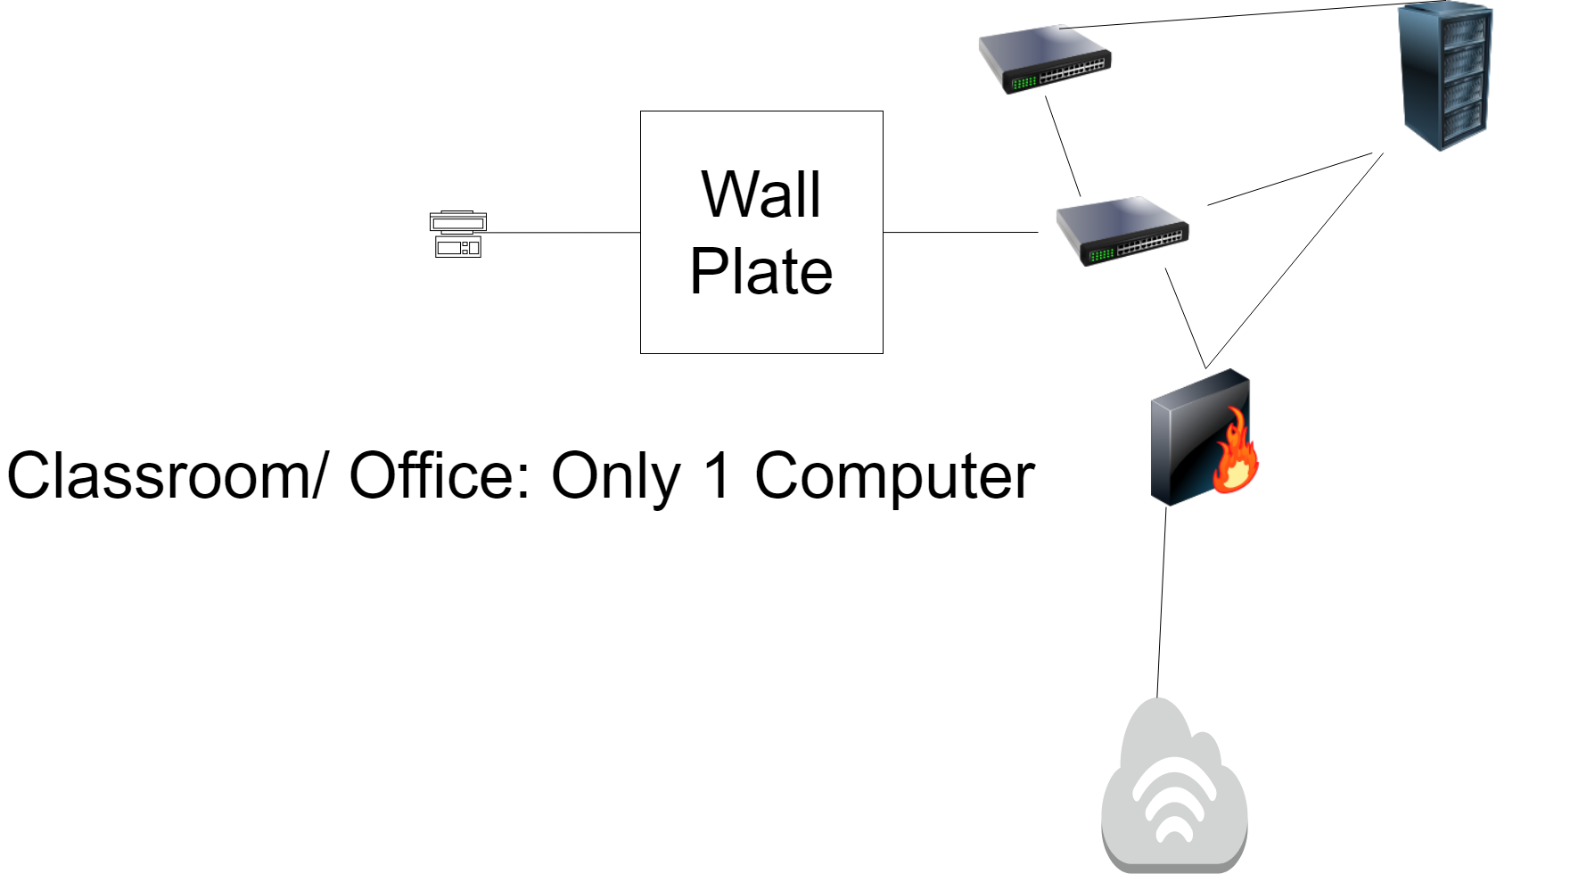

#### **Figure 4: Lab**

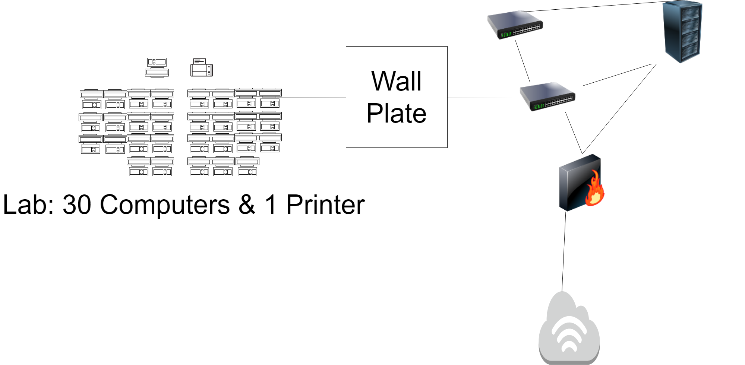

## **7 System Components & Statement of Work**

|  |  |  |  |  |  |
| --- | --- | --- | --- | --- | --- |
| **Item** | **Units** | **Cost per Unit** | **Total Cost** | **URL** | **Labor Cost** |
| Computers | 322 | $1,150 | $370,300 | [HP ProDesk 600 G6 Desktop Mini PC](https://www.hp.com/us-en/shop/pdp/hp-prodesk-600-g6-desktop-mini-pc?intel=10gi5&a=1&jumpid=cs_con_nc_ns&utm_medium=cs&utm_source=ga&utm_campaign=HP-Store_US_BRA_PS_CPS_Hgm_Intel_CCF_Google_Catch_All_PLA&utm_content=sp&adid=442574578752&addisttype=gpla&454Q0UA%23ABA&cq_src=google_ads&cq_cmp=6956329427&cq_con=105631357871&cq_term=&cq_med=pla&cq_plac=&cq_net=g&cq_pos=&cq_plt=gp&gclid=Cj0KCQiAkZKNBhDiARIsAPsk0WiUDaYNSPzAr6Rot4pBLw_0F8xJuuUMDt49fv0qBECA0ENRVwbBFRUaAoWTEALw_wcB&gclsrc=aw.ds) | $1,000 |
| Monitors | 322 | $379 | $122,038 | [HP Business E243m 23.8"](https://www.officedepot.com/a/products/3081769/HP-Business-E243m-238-Full-HD/?utm_source=google&utm_medium=cpc&mediacampaignid=71700000037439704_1447190395&gclid=Cj0KCQiAkZKNBhDiARIsAPsk0WjEe8H0dlLMwvGPsQG-LNcRlzSq1_7HBkwfnZPlHDoLBht7LrE-I-EaAsJAEALw_wcB&gclsrc=aw.ds) | $0 |
| Printers | 11 | $599 | $6,589 | [Xerox WorkCentre Multifunction Color Duplex Network Laser Printer](https://www.dell.com/en-us/work/shop/xerox-workcentre-multifunction-color-duplex-network-laser-printer-6515-dn/apd/aa116060/printers-ink-toner?gacd=9646510-1025-5761040-266794296-0&dgc=st&ds_rl=1282786&gclid=Cj0KCQiAkZKNBhDiARIsAPsk0WjGx2Jd7MmH5ewAhaSujqNBIRKnpyc-EMAGLEaBjRHCSDnlDGv8Z58aAsKWEALw_wcB&gclsrc=aw.ds&nclid=0cwuuxVEM19FKrlVfEEGiKzdOsb9jX7rHz3xucFBFRi0ZIM2K2KsYM7fJ_Z7pvjA) | $0 |
|  |  |  |  |  |  |
| Server | 1 | $3,377 | $3,377 | [HP Server Tower](https://www.amazon.com/Hpe-ProLiant-ML350-Gen10-Performance/dp/B07QGR8R2C/ref=asc_df_B07QGR8R2C/?tag=&linkCode=df0&hvadid=363067789809&hvpos=&hvnetw=g&hvrand=10629974732732160074&hvpone=&hvptwo=&hvqmt=&hvdev=c&hvdvcmdl=&hvlocint=&hvlocphy=9031218&hvtargid=pla-783152560750&ref=&adgrpid=82977529144&th=1) | $300 |
| Server Rack | 1 | $0 | $0 | - | $0 |
| Cable Management | 1 | $203 | $203 | [APC Rack Cable Management Panel](https://www.dell.com/en-us/work/shop/apc-rack-cable-management-panel-42u/apd/a7371062/pc-accessories?gacd=9646510-1025-5761040-266794296-0&dgc=st&ds_rl=1282786&gclid=Cj0KCQiAkZKNBhDiARIsAPsk0WhHwNdX0D-8HVN5IZlXuNlJTU-dIBAMi9ErgbjJoNyaY4slosm35N4aAtg0EALw_wcB&gclsrc=aw.ds&nclid=0cwuuxVEM19FKrlVfEEGiKzdOsb9jX7rHz3xucFBFRi0ZIM2K2KsYM7fJ_Z7pvjA) | $0 |
| 24-Port Switch | 2 | $1,286 | $2,572 | [CISCO Catalyst 9200](https://www.newegg.com/cisco-c9200-24p-e-24-ports-switch-24-x-rj45-4-x-sfp/p/N82E16833960619) | $75 |
| Router | 1 | $1,397 | $1,397 | [Cisco Small Business ISR4331](https://www.newegg.com/cisco-small-business-isr4331-sec-k9-10-100-1000mbps/p/N82E16833150522) | $50 |
| Uninterruptible Power Supply | 1 | $285 | $285 | [Belkin UPS](https://www.newegg.com/cisco1921-k9-10-100-1000mbps/p/N82E16833120491) | $75 |
| Licenses | 322 | $0 | $0 | Windows 10 | $200 |
| Licenses | 1 | $500 | $500 | [MS Server 2019](https://www.trustedtechteam.com/products/microsoft-windows-server-2019-standard-16-core?dfw_tracker=22777-12556411568245&gclid=Cj0KCQiAkZKNBhDiARIsAPsk0WgEGvr6oREqXRHyfBGY8JRozgFQ9YYwRaZb-q5O6Rco4nZyaHKpQi4aAtlZEALw_wcB) | $1,000 |
| Licenses | 322 | $0 | $0 | Office 365 | $200 |
| Document Cameras | 11 | $233 | $2,563 | [Epson DC-07 Document Camera](https://www.dell.com/en-us/work/shop/epson-dc-07-document-camera-document-camera/apd/aa290005/projectors-projector-accessories?gacd=9646510-1025-5761040-266794296-0&dgc=st&ds_rl=1282786&gclid=Cj0KCQiAkZKNBhDiARIsAPsk0Wgfa7O10xr5lZGX3r5-DYoxaM-xuGJ_xxl23qCxdCCWUoLdNMkkT-gaAv6wEALw_wcB&gclsrc=aw.ds&nclid=0cwuuxVEM19FKrlVfEEGiKzdOsb9jX7rHz3xucFBFRi0ZIM2K2KsYM7fJ_Z7pvjA) | $100 |
|  |  |  |  |  |  |
| Multimedia Projectors | 19 | $370 | $7,030 | [Epson - VS260 XGA](https://www.bestbuy.com/site/epson-vs260-xga-1024-x-768-3lcd-projector-white/6428483.p?skuId=6428483) | $200 |
| Speakers | 19 | $83 | $1,577 | [Dual LU53PW 5.25" 3-Way Indoor/Outdoor Speakers](https://www.walmart.com/ip/Dual-LU53PW-5-25-3-Way-Indoor-Outdoor-Speakers-White/10298561?wmlspartner=wlpa&selectedSellerId=0) | $200 |
| USB Cables | 18 | $10 | $180 | [USB 3.0 Cable](https://www.amazon.com/Cable-Matters-Male-Black-Feet/dp/B00HSS9LEI/ref=asc_df_B00HSS9LEI/?tag=hyprod-20&linkCode=df0&hvadid=309743296044&hvpos=&hvnetw=g&hvrand=3120135168506940979&hvpone=&hvptwo=&hvqmt=&hvdev=c&hvdvcmdl=&hvlocint=&hvlocphy=9030957&hvtargid=pla-571722154748&psc=1) | $0 |
| Keyless Door Access | 8 | $2,500 | $20,000 | - | $0 |
|  |  |  |  |  |  |
| Cat 6 Cabling 1000 ft Rolls | 2 | $195 | $390 | [Cat6 Direct](https://www.amazon.com/dp/B01MF56VUR/ref=redir_mobile_desktop?_encoding=UTF8&aaxitk=5fa90673efa0ea1c7237dae8a196b81c&hsa_cr_id=4635547250101&pd_rd_plhdr=t&pd_rd_r=cc6b6e70-1e39-4e9d-9874-562a05bd58a6&pd_rd_w=F93eX&pd_rd_wg=OHI2J&ref_=sbx_be_s_sparkle_mcd_asin_0_title&th=1) | $1,000 |
| RJ-45 Connectors 100 pk | 2 | $19 | $38 | [Cable Matters 100 Pack RJ45 Modular Plugs](https://www.amazon.com/Cable-Matters-100-Pack-Modular-Stranded/dp/B004D5RFCE/ref=asc_df_B004D5RFCE/?tag=hyprod-20&linkCode=df0&hvadid=309776868400&hvpos=&hvnetw=g&hvrand=5182754624023686142&hvpone=&hvptwo=&hvqmt=&hvdev=c&hvdvcmdl=&hvlocint=&hvlocphy=9031218&hvtargid=pla-570218615683&psc=1) | $0 |
| Firewall | 1 | $412 | $412 | [CISCO ASA5510-SEC-BUN-K9 ASA 5510 SSM Security Appliance](https://www.newegg.com/cisco-asa5510-sec-bun-k9-wired/p/N82E16833120080?item=9SIA4A0AYH7952&source=region&nm_mc=knc-googlemkp-pc&cm_mmc=knc-googlemkp-pc-_-pla-it+wholesalers-_-network+-+firewalls-_-9SIA4A0AYH7952&gclid=Cj0KCQiAkZKNBhDiARIsAPsk0WiTfYDdie896GayobN9N6m459gW2Ir1XcV17TE8k9eyO8ehsilaL1QaAlhiEALw_wcB&gclsrc=aw.ds) | $50 |
| Wireless Access Points | 2 | $132 | $264 | [NETGEAR Wireless Access Point (WAC540)](https://www.amazon.com/NETGEAR-Insight-Tri-Band-Wireless-included/dp/B07PF1YFY7/ref=asc_df_B07PF1YFY7/?tag=&linkCode=df0&hvadid=343187928868&hvpos=&hvnetw=g&hvrand=6600540214732576256&hvpone=&hvptwo=&hvqmt=&hvdev=c&hvdvcmdl=&hvlocint=&hvlocphy=9031218&hvtargid=pla-793491079117&ref=&adgrpid=68968886357&th=1) | $100 |
| **1** Microsoft offers Office 365 & Windows 10 for free to all schools/ colleges (e.g. CSULA) |  |  | $539,715 |  | $4,600 |
| **2** There is no need to buy another server rack |  |  |  | **Grand Total** | **$544,315** |

## **8 Disaster Recovery Plan**

* Automatic backup of data on all servers to secondary HDDs
  + Using Windows Backup Service. (off-site backup service is recommended)
  + Set up to run automatically every night of the week
    - Normal backup on Friday nights
    - Incremental backups every other night
  + Will also utilize the recovery console in Windows 10 with restore points stored twice daily

## **9 Acceptance & Authorization**

The terms and conditions of the Professional Services Agreement apply to the services and products provided under this Statement of Work.

In WITNESS WHEREOF, the parties hereto each acting with proper authority have executed this Statement of Work, under seal.

California State University, Los Angeles Golden Eagle, Inc.



Full name Full name



Title Title



Signature Signature



Date Date

## **10 System Set Up Documentation**

### **10.1 Physical Network Components Architecture**

Salazar Hall LAN

* Cisco 4331 core router for entire Salazar Hall building LAN, connected campus LAN or directly to ISP.
* Cisco 3650 master switch connecting 3rd floor’s main switch to core router Cisco 4331.
* Cisco 9200 floor 3 main switch connecting all the rooms on the 3rd floor to the master 3650 switch.
* Cisco 9200 switch will connect hosts in each computer lab to the 3rd floor main switch.
* Single computer classrooms will be connected over an RJ-45 wall plate.
* TP-Link Archer AX1100 will be deployed in two centralized locations.
* MS Server 2019 provides DNS and Domain Controller services.
* Computer lab 358 will have a dedicated networking closet for secondary internal networks where students can practice their network configurations and build projects on real networking equipment, with the possibility of remote access.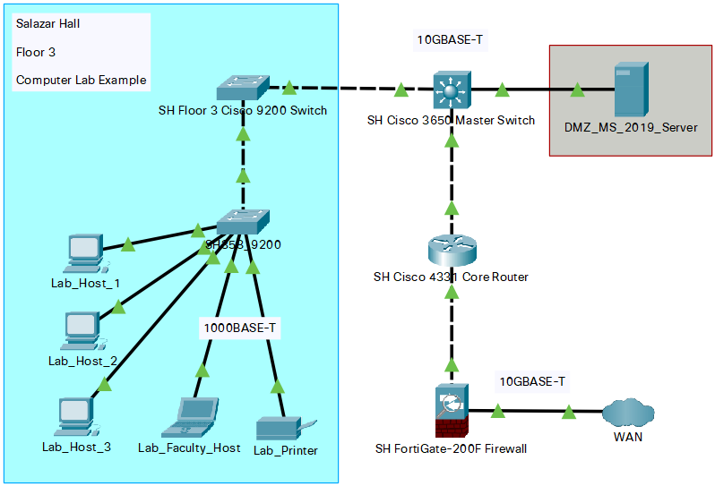

### **10.2 Network Security Architecture**

* Salazar Hall does not serve as a Cal State LA administration building, thus does not host services as web servers, mail servers, databases, and similar.
* The University IT department will be able to implement Network Access Control to enforce network policies and user authorization.
* FortiGate-200F firewall with a throughput of 3.5 Gbps and sufficient user support will be deployed on the edge of the network edge.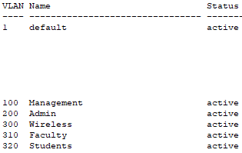
* 802.1x wireless security standard supporting current WPA, WPA2 protocols, but is also WPA3 ready.
* Separate VLANs will be configured for management, administrators, wireless, faculty hosts, student hosts.
* DMZ will be configured to separate the MS server from the rest of the network.

### **10.3 Active Directory Domain Services**

* ADDS will be deployed on Microsoft Server 2019 that will function as a Domain Controller. High end recommended specifications; Dual Intel Xeon 2690v3, 128GB RAM, 2x 120GB SSD and 5x 4TB HDD configured in RAID 5. Server manufacturer Supermicro or Dell with onboard IPMI or BMC.
* AD will be configured as SLZR300X domain which will be part of Cal State LA Active Directory tree. This domain will contain object information such as faculty staff and student information, host computers and other hardware devices, software applications, policies, and unique and security identifiers.
* Objects of the SLZR300X domain will be stored in the AD database on the server. Hard drives configured in RAID 5 will provide the best storage solution due to their good performance and fault tolerance in case of driver failure. Finally, database objects will be backed up on Cal State LA servers outside of the Salazar Hall in the administration building.

